

**Fundamentals Of Programming Lab manual 74**

**Name: Muhammad Amad Naeem**

**Section: ME-15 B**

**CMS ID: 467469**

**Task 1:**

**#include<iostream>**

**using namespace std;**

**int main(){**

**int arr[10];**

**cout<<"Enter 10 integers"<<endl;**

**for(int i=0;i<=9;i++){**

**cin>>arr[i];**

**}**

**cout<<"arrey of 10 integers is:";**

**for(int j=0;j<=9;j++){**

**cout<<arr[j]<<' ';**

**}**

**return 0;**

**}**

**Output:**

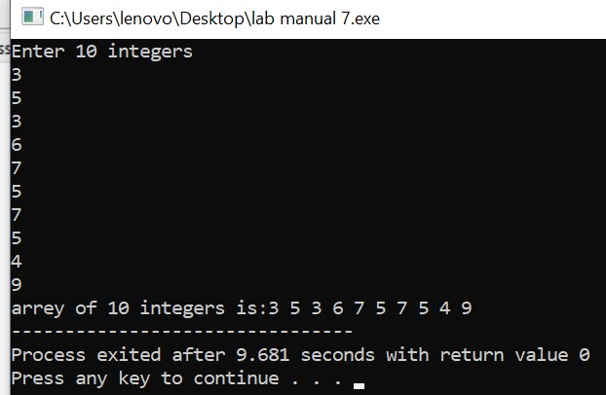

**Task 2:**

**#include<iostream>**

**using namespace std;**

**int main(){**

**int arr[5],sum=0,product=1;**

**cout<<" Enter 5 integers"<<endl;**

**for(int i=0;i<=4;i++){**

**cin>>arr[i];**

**}**

**for(int j=0;j<=4;j++){**

**product=product*arr[j];**

**}**

**for(int a=0;a<=4;a++){**

**sum=sum+arr[a];**

**}**

**cout<<"product of all the integers of arrrey: "<<product<<endl;**

**cout<<"the sum of all the integers of arrey: "<<sum;**

**}**

**OutPut:**



**Task 3:**

**#include<iostream>**

**using namespace std;**

**int main(){**

**int size;**

**cout<<"enter the size of diamond: ";**

**cin>>size;**

**int half=size/2;**

**char arr[size];**

**for(int i=0;i<size;i++){**

**arr[i]=' ';**

**}**

**for(int i=0;i<=half;i++){**

**for(int j=0;j<size;j++){**

**arr[half-i]='*';**

**arr[half+i]='*';**

**cout<<arr[j];**

**}**

**cout<<endl;**

**}**

**for(int i=size;i>0;i--){**

**arr[i]='*';**

**}**

**for(int i=half;i>=0;i--){**

**for(int j=0;j<size;j++){**

**arr[half-i]=' ';**

**arr[half+i]=' ';**

**cout<<arr[j];**

**}**

**cout<<endl;**

**}**

**}**

**Output:**

